le 28 septembre au 2 octobre
Bonjour Grade Five families,

Reminders for the week:

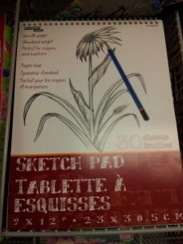
- At Meet the Teacher, I mentioned that we would like to create an art portfolio for your child to bring home at the end of the year. If you would like me to pick one up for you, would you please send the sketch pad or the $1.25 in this week? We have some art pieces that are ready to be filed. If you would prefer to purchase one yourself, they can be found at the Dollarstore. I have attached an example of what we are looking for.
- I have a website this year! This will be a learning process for me and I welcome all feedback. The site is http://mmemcdonald5.weebly.com/. It is my goal to update this at least weekly. I am also in the process of creating an e-mail distribution list for my class. I will be adding all the addresses I have from the forms you sent in at the beginning of the year. If you have not received an e-mail from me by the end of the week, please let me know at laura.mcdonald@nbed.nb.ca.
Homework for the week:
- Review: This week for homework please have your child continue to practice their math facts. It is also beneficial for students to review the names of the numbers 1-1000 as there is still some confusion with some numbers. It is crucial that these become automatic for your child.
- Reading: I am currently in the process of testing your child’s reading level. As soon as this is completed (mid-week) I will be encouraging your child to bring home leveled books so they can read nightly. This week your child will be asked to read for fluency with the poem in their duotangs.
- Math: This week students will be practicing multiplication with their 4 and 8 timetables. Please have your child complete the attached sheet. We will also be preparing for their first test in Math at school.
- Spelling: This week, your child received all the spelling words for the whole school year. The dates are all included so that you know which words they will need to study for their weekly spelling tests. The tests will be on Friday mornings. Please feel free to take this sheet out of your child’s duo-tang to keep them home. I will be posting it on my website as well.

If you have any questions for me, please let me know by phone (357-4098) or by email (laura.mcdonald@nbed.nb.ca). Thanks for all your support!!

Mme McDonald

